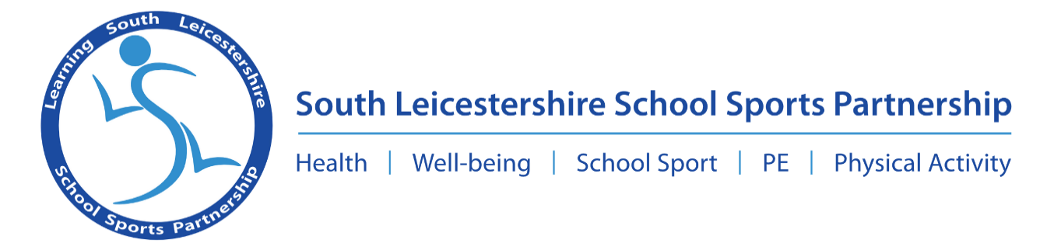

South Wigston High School, St Thomas Rd, South Wigston, Leicester. LE18 4 TA
www. learningsouthleicestershiressp. org. uk

Dear Parent/Guardian,

This year Children’s Mental Health week is February 6th – February 12th, the theme for the week is ‘Let’s Connect’, to find out more information visit: www.childrensmentalhealthweek.org.uk/. The South Leicestershire School Sports Partnership (SLSSP) in conjunction with Active Oadby and Wigston, Active Blaby and Active Harborough have created a challenge to encourage Key Stage 2 pupils to connect with others.

We're asking Year 3-6 children to write a positive message about mental health and draw a picture of how they connect with others, on a puzzle piece. Click here to download the puzzle piece template. We hope to share the children’s puzzle to raise awareness of Children’s Mental Health and connect children from across South Leicestershire. Pupils may want to connect their puzzle piece with their class and friend as a visual representation of the theme, ‘Let’s Connect’.

We're encouraging parents, schools and teachers to share the puzzle pieces with us at SLSSP and tag in @lslssp along with @activeoadbywigs, @activeblaby or @SportinHarb using the hashtag #letsconnectpuzzle. Every tweet will be entered into a prize draw to win Amazon vouchers.

Let's flood social media and connect with others during Children's Mental Health Week 2023.

Throughout the week, the South Leicestershire School Sport Partnership will be sharing useful mental well-being tips, contacts, advice and support via our social media channels, so make sure you check them out.

If you have any additional questions about the mental well-being task or if you’d like any more information feel free to contact me on the email address; mkhan11@southwigston.leics.sch.uk

Yours sincerely,
Hussein Khan
South Leicestershire School Sports Partnership

South Leicestershire School Sports Partnership
Supporting South Leicestershire Schools to provide opportunities for all young people

